Experiment 12

12.1.1Phone number Database Management:

Algorithm:
Step 1: Start
Step 2: Read an integer n (number of operations)
Step 3: Initialize an empty dictionary ph to store contacts
Step 4: Repeat the following steps n times:
Step 5: Read input and split it into a list cmd
Step 6: Check the first element of cmd (command type):
If cmd[0] == "ADD"
- Store the contact in dictionary
- ph[cmd[1]] = cmd[2]
Else if cmd[0] == "REMOVE"
- Remove the contact from dictionary if it exists
- ph.pop(cmd[1], None)
Else if cmd[0] == "DISPLAY"
If dictionary ph is empty:
- Print "No contacts"
Else:
- Sort the contact names
- For each name in sorted order:
- Print name: ph[name]
Step 7: End loop
Step 8: Stop

Flowchart:
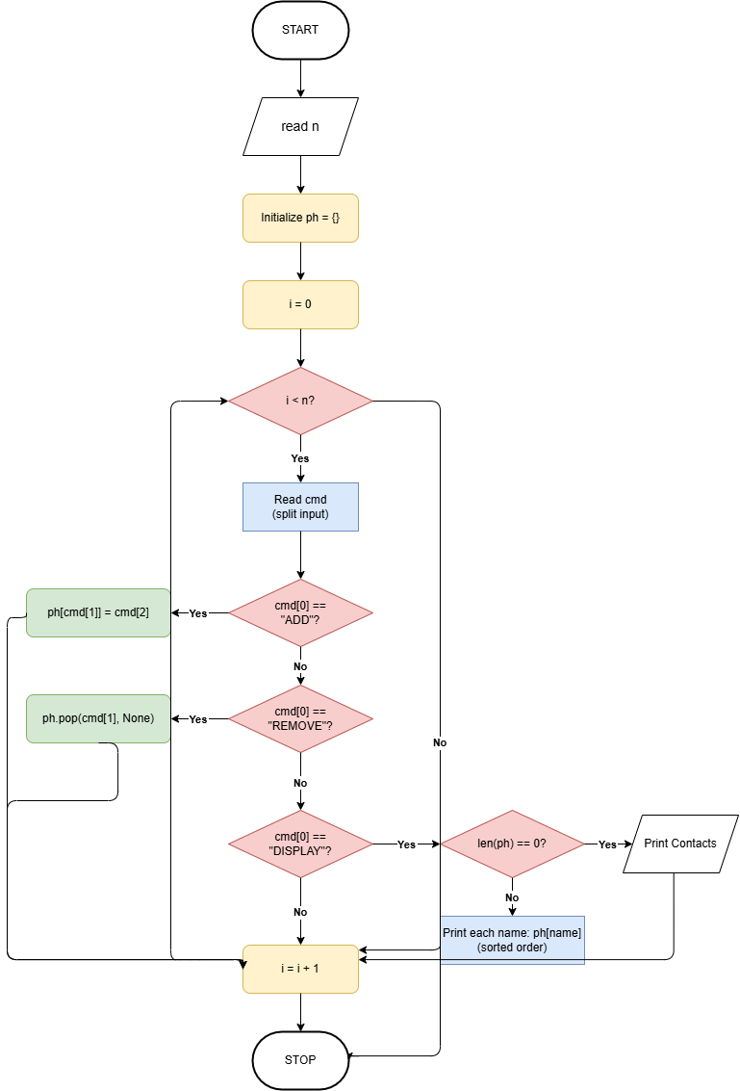

Execution:
